Pass Task 1 – Spike: The contest

Goals:
This section is an overview highlighting what the task is aiming to teach or upskill.

The purpose of this task is to showcase my ability to work with a single-activity application, effectively manage activity states, use Logs, create layouts, implement listeners, and enable localisation.

This is done by creating a simple game which tracks scores and contains 3 buttons which increase, decrease, and reset the score.

The following list outlines the goal broken down into more specific knowledge gaps involved in the goal.

- Ability to develop listeners.
- Ability to develop linear and constraint layouts.
- Save the score on rotation via saveInstanceState or a ViewModel.
- Allow multiple language support.
- Implement audio functionality in the program.
- Understand how to debug and read log messages.

Tools and Resources Used
This section lists related software, tools, libraries, API's, and other resources used for this knowledge gap.

- Android Studio
- Demo of program (Link)
- Media player documentation (Link)
- YouTube video on localisation (Link)

Knowledge Gaps and Solutions
This section presents the listed knowledge gaps and their solutions with supporting images, screenshots and captions where appropriate/required.

Gap 1: issue with supporting multiple languages.

I had some difficulties with implementing multiple language support. I came across this video which showcased how I need to structure my strings.xml and folder correctly and utilise a plugin to support multiple languages.

Also in the first lesson of this course we understood the importance of naming in string.xml and not hardcoding as that affects localisation.

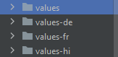
I had added localisation for multiple languages ranging from German, French and Hindi.

I will display my screens in French as denoted below

ORIGINAL
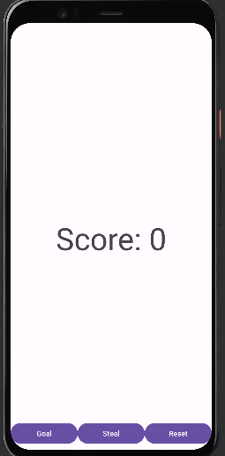 | 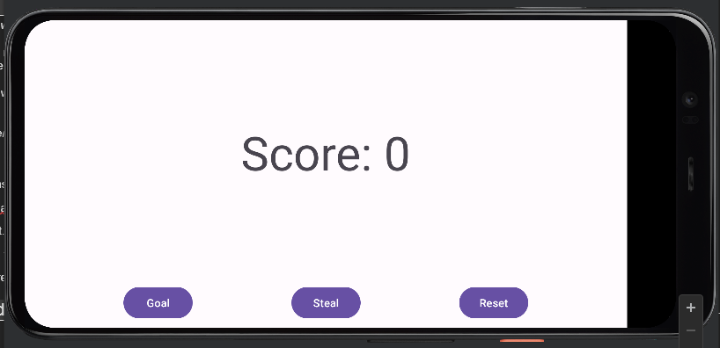

TRANSFORMED

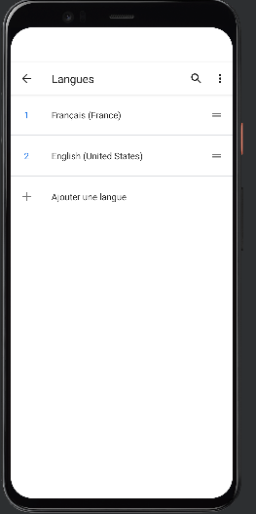

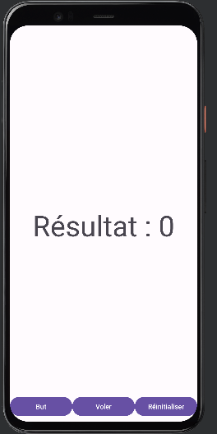 | 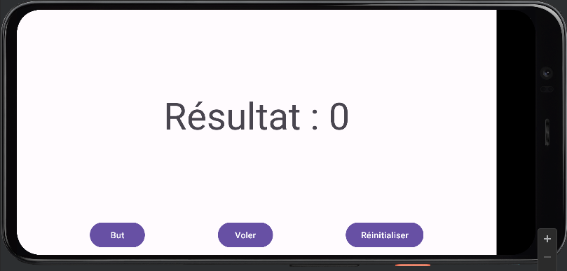

Gap 2: issue with screen rotation (app crashes)

Earlier in the design process when running the app and rotating it for some reason the app would crash.

I used the logs to determine the error

FATAL EXCEPTION: main Process: swinburne.app, PID: 31843 java.lang.RuntimeException: Unable to start activity ComponentInfo{swinburne.app/swinburne.app.MainActivity}:Caused by: android.content.res.Resources$NotFoundException: Resource ID #0x7f0b005a

I will ensure to take a screenshot next time

The error was due to a resource not found.

The issue was when you only have one layout file in directory which is only portrait it will crash as you do not have a corresponding file i.e res/layout-land. This is because the app crashes as it tries to access an id that that isn't in the default layout when the device is in landscape mode.

The fix is very simple simply make a new layout with landscape orientation and ensure the ids are the same.

This issue was difficult to fix as I could not find definitive guidance online as this is so fundamentally easy but I due to my first time with this layout notion could not understandOpen Issues and Recommendations

This section outlines any open issues, risks, and/or bugs, and highlights potential approaches for trying to address them in the future.

At this stage there is not any open issues or bugs that I have identified. In terms of design I have read that using MediaPlayer for simple applications is satisfactory, however, when building large scale applications it is wiser to utilise SoundPool because of the resources taken up by Media Player which I also ensured to release after each use.

I would make this app utilising SoundPool to get a diverse range of sounds and a possible extension I would make is to tailor the sounds of goal, steal and reset with the specific language setting of the mobile application.

